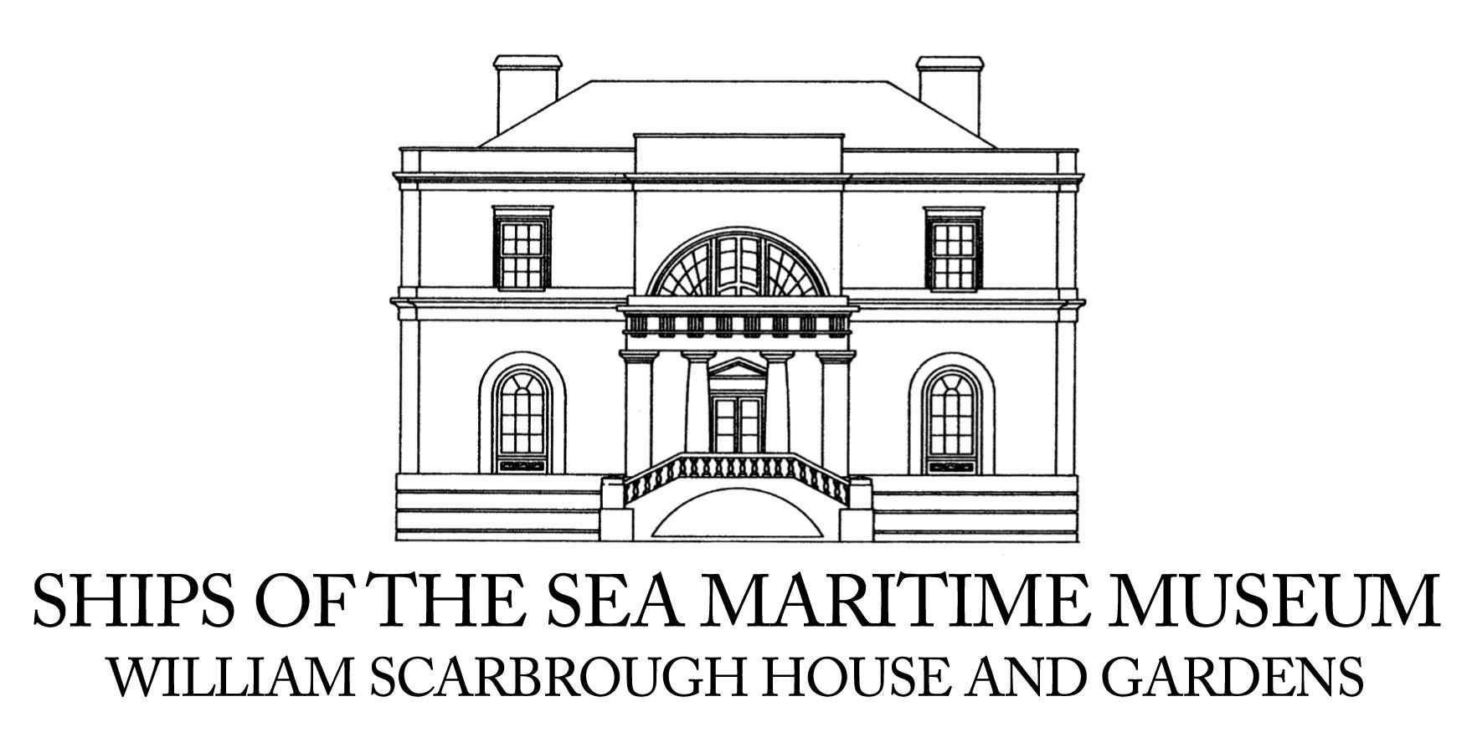
NEWS RELEASE

FOR IMMEDIATE RELEASE

Media Contact:
Allison Hersh
Capricorn Communications
912.441.1285 | pr@capricorncomm.com

Ships of the Sea Maritime Museum to Present
“Beyond the Plate: Sea and Sky” Exhibition Featuring Original Art by Rob Strati from Sept. 25 through April 12

Exciting new solo exhibition to showcase nautical-inspired mixed-media work, limited-edition prints and a site-specific installation

SAVANNAH, Ga. (August 7, 2025) – Ships of the Sea Maritime Museum—an acclaimed museum in Savannah, Ga. dedicated to celebrating and preserving America’s maritime legacy—is delighted to present “Beyond the Plate: Sea and Sky,” an exciting new solo exhibition featuring nautical-inspired, mixed-media art by Rob Strati, from Sept. 25, 2025 through April 12, 2026. In addition, Ships of the Sea Museum will host a range of special events, including a Donor Preview Reception and Opening Reception with Rob Strati on Thurs., Sept. 25, “Art, Conversation & Creative Play: An Evening with Rob Strati” on Fri., Sept. 26 and a free Family Day on Sun., Oct. 26.

Following the success of the museum’s two recent exhibitions—“Sea of Ink: Savannah Maritime Tattoos,” which closes on August 31 after an extended run due to its popularity, and “Waves of Wonder,” which won a Coastal Museum Association’s Excellence in Exhibition Award—“Beyond the Plate” will showcase new work by one of America’s hottest contemporary artists. Strati has recently enjoyed sold-out exhibits at Duane Reed Gallery in St. Louis and FREMIN Gallery in New York and has sold work to top international art collectors in New York, London, Hong Kong, Dubai and beyond.

“We’re thrilled to present Rob Strati’s first museum show in Georgia and can’t wait to share his work with Savannah residents and guests to our city,” said Molly Carrott Taylor, Executive Director of Ships of the Sea Maritime Museum, who was captivated by Strati’s mixed-media work after first discovering it on Instagram. “Rob stands apart as one of America’s most imaginative contemporary artists and is attracting significant attention for his work that, quite literally, moves off the paper.”

Strati’s art incorporates broken porcelain plates that have been embellished and adorned with creative details. “Beyond the Plate: Sea and Sky” will showcase the artist’s latest bold, kinetic mixed-media works and limited-edition prints as well as an ambitious site-specific installation that will be suspended from the ceiling of the Ships of the Sea atrium.

Ships of the Sea Maritime Museum Curator Tania Sammons, who curated the “Beyond the Plate” exhibit, describes Strati’s work—as well as his creative process—as fundamentally hopeful.

“Rob takes something broken and seemingly unusable and gives it new life and beauty,” Sammons explained. “People resonate with the idea of regeneration from something old and broken. They also enjoy the element of surprise and the narrative components of Rob’s works. This series is a metaphor for life. We cannot undo things when something bad happens, but we can create something new, and maybe even better.”

Strati’s latest series was inspired by a porcelain plate from his wife’s late mother, which accidentally fell and broke into fragments. In order to preserve the shards of the shattered plate, and the memory of someone vitally important to both him and his wife, the artist began working on his “Fragmented” series, using pen and paper to “explore the possibilities of things broken and the stories that can evolve from the pieces left behind.”

“I have experienced great loss and traumas where something happens unexpectedly and irrevocably, and these works speak to the process we go through when those kinds of things happen,” Strati explained. “Over time something starts to shimmer again, and a new world evolves – something tied to the past, yet new and different. The fragments and the breaks become part of the beauty of that new reality.”

Each piece of Strati’s art starts with the breaking of a porcelain plate and takes approximately two weeks to complete. Although the artist is rigorous about his creative process, he always allows space for spontaneous ideas to emerge from the fragments. Over time, he has learned important lessons about art and life by creating new works of art from broken shards.

“This creative process has opened me up to letting go of control each step of the way,” he said. “It’s fun and exciting as well as nerve-racking and labor intensive. I try to mimic the border of the plate and the central image to recreate the sense of a ‘plate,’ but after that, as the drawing moves into the open white space, there is more freedom and excitement and randomness that happens there.”

Strati describes his work as a “mix of chaos and control” that is constantly evolving. He hopes his upcoming exhibition at Ships of the Sea will inspire visitors to think about time, creativity and beauty in fresh, new ways.

“I hope people see the lines that are drawn from the past into the present and how what is seen as ‘old’ has the power of the future in it,” he explained. “I hope they see that the museum is full of stories, creativity and ideas that have evolved, often in unexpected ways, over centuries. I hope they have a sense of adventure, beauty and empowerment and see that in everyday experience and accidents, we have opportunities to make something new.”

Originally from Boston, Strati grew up in Columbus, Ohio and earned a B.A. in History of Art from Ohio State University. His art has been exhibited at leading international museums and art galleries and has been featured in The Art Newspaper, Whitehot Magazine, Reclaim, Beaux Arts, Sculpture Magazine, Vice and The Village Voice. Strati’s work and “Beyond the Plate” will also be featured in ARTS Southeast’s fall issue of IMPACT Magazine in October 2025.

All of the art in “Beyond the Plate” will be for available for purchase, with a portion of the proceeds benefiting Ships of the Sea Maritime Museum.

RELATED EVENTS:
Thursday, Sept. 25 | 4:30 - 5:30 p.m.
Donor Preview Reception with Rob Strati
Please contact Alison Cooley at Ships of the Sea at alisoncooley@shipsofthesea.org for information.

Thursday, Sept. 25 | 5:30 to 7:30 p.m.
Opening Reception with Rob Strati
Meet artist Rob Strati and experience the new “Beyond the Plate: Sea and Sky” exhibition at Ships of the Sea Maritime Museum.

Friday, Sept. 26 | 5 to 7 p.m.
Art, Conversation & Creative Play: An Evening with Rob Strati
This special evening will feature artist Rob Strati in conversation with Ships of the Sea Executive Director Molly Carrott Taylor and Curator Tania Sammons as well as a hands-on art workshop, drinks and light snacks. Attendees will have the opportunity to choose patterned paper to tear, trade and reassemble, transforming the collage into a finished artwork by drawing images and motifs inspired by the original fragments. Tickets are $25 per person and are available at shipsofthesea.org.

Sunday, Oct. 26 | 1-4 p.m.
Family Day
In honor of “Beyond the Plate: Sea and Sky,” Ships of the Sea Maritime Museum will host a special Family Day, which is free and open to the public, featuring hands-on activities for children of all ages.

Ships of the Sea Maritime Museum is open daily from 10 a.m. to 5 p.m. (last admission at 4:30 p.m.). Tickets are $17.50 for adults; $14.50 for students, seniors 65+, active-duty military and veterans; and free for children ages 5 and under. Discounted family and group tickets are also available. Additional information is available at shipsofthesea.org.

ABOUT SHIPS OF THE SEA MARITIME MUSEUM:
Founded in 1966, Ships of the Sea Maritime Museum is dedicated to celebrating and preserving Savannah, Ga’s maritime legacy. The museum is housed within the William Scarbrough House, a stately Greek-Revival residence designed in 1819 by acclaimed architect William Jay for William Scarbrough, the first president of the Savannah Steamship Company. The museum features nine galleries showcasing ship models, paintings, and maritime antiques, and has the largest private garden in Savannah’s National Historic Landmark District. Today, Ships of the Sea Maritime Museum serves as a testament to Savannah’s rich maritime legacy as well as its as well as its bright future. Learn more: shipsofthesea.org or 912.232.1511

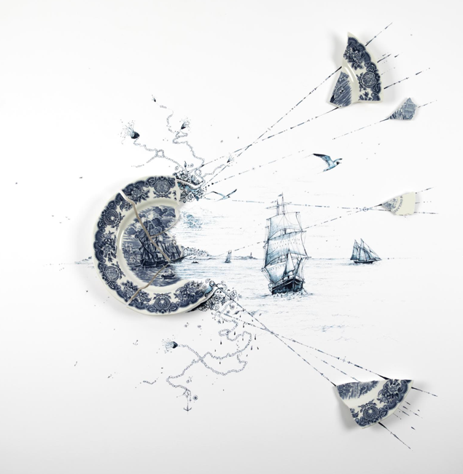

PHOTO CAPTION: “Beyond the Plate: Sea and Sky,” an exciting new exhibit at Ships of the Sea Maritime Museum in Savannah, Ga., will showcase Rob Strati’s mixed-media works that incorporate broken porcelain plates embellished with imaginative details. “Beyond the Plate” will open on Sept. 25, 2025 and run through April 12, 2026.

NOTE TO MEDIA:

Please click HERE to download high-res images.

Advance interviews about the “Beyond the Plate” exhibit are available with artist Rob Strati, Ships of the Sea Maritime Museum Executive Director Molly Carrott Taylor and exhibition curator Tania Sammons. Please contact Allison Hersh at pr@capricorncomm.com or 912-441-1285 to schedule media interviews.

###

